Exp No: 14 EMBEDDED C PROGRAM TO DISPLAY “HELLO WORLD” MESSAGE
AIM:
To write an Embedded C program to display “HELLO WORLD” message using Keil software.
SOFTWARE REQUIRED:
• Keil software
Program:
#include <reg51.h>
#include <stdio.h>

void main(void)
{
SCON = 0x50; /* SCON: Mode 1, 8-bit UART, enable receiver */
TMOD = 0x20; /* TMOD: Timer 1, Mode 2, 8-bit reload */
TH1 = 0xFD; /* TH1: Reload value for 9600 baud rate */
TR1 = 1; /* TR1: Start Timer 1 */
TI = 1; /* TI: Set TI to send the first character */

while (1)
{
printf("Hello World!\n");
}
}
OUTPUT:
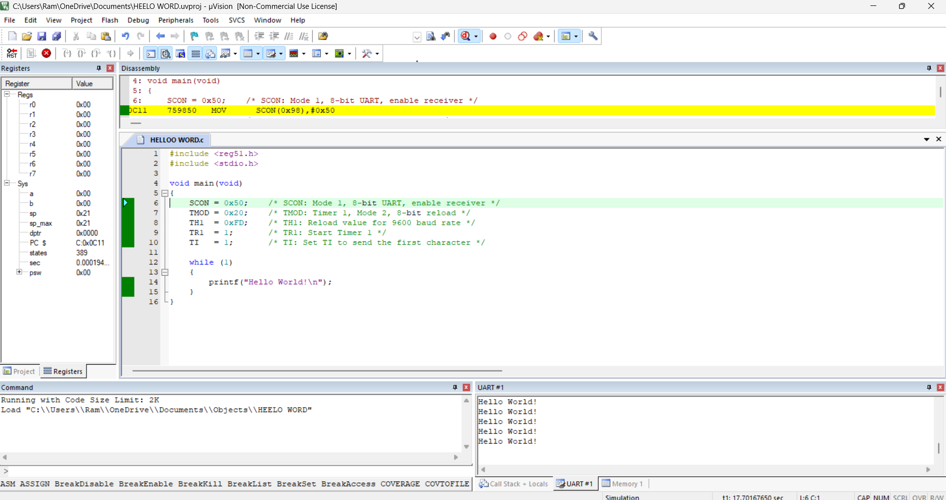
RESULT:
Thus the program has been successfully verified and executed.

